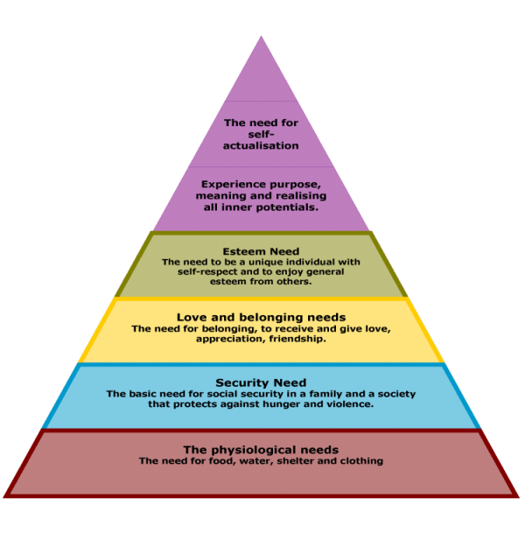
Motivation: Maslow’s Hierarchy

Imagine that there has been a zombie apocalypse. There are only a few humans left and you are trying surviving with a group of about twenty other people. You decide that you are going to try and meet Maslow’s Hierarchy of need in order. What might you attempt to do to meet each need? Try to come up with at least 3 things for each level of needs.

- Physiological Needs:
2. Security Needs
3. Love and Belonging Needs:
4. Esteem Needs:
5. Purpose:
6. Self-Actualization

Try to think of a classroom. Pretend you are a teacher. What could you do to satisfy each level of needs?
1. Physiological Needs:
2. Security Needs:
3. Love and Belonging Needs:
4. Esteem Needs:
5. Purpose:
6. Self-Actualization

